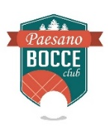 Paesano Bocce Club Registration Form

Name:_________________________________________
Spouse:________________________________________
Address:________________________________________
City:______________________ State:________________ Zip Code:_______________
E-mail:______________________________
Phone:______________________________
Individual Membership $100.00 __________
Family Membership (Couple) $150.00 __________
Under 21 $20.00 __________
Please remit to: Paesano Bocce Club, 10006 SE 40th Ave. Milwaukie, Oregon 97222

