Gresham Ford’s Mixed Doubles Tournament
Sunday August 11^{th,} 2019
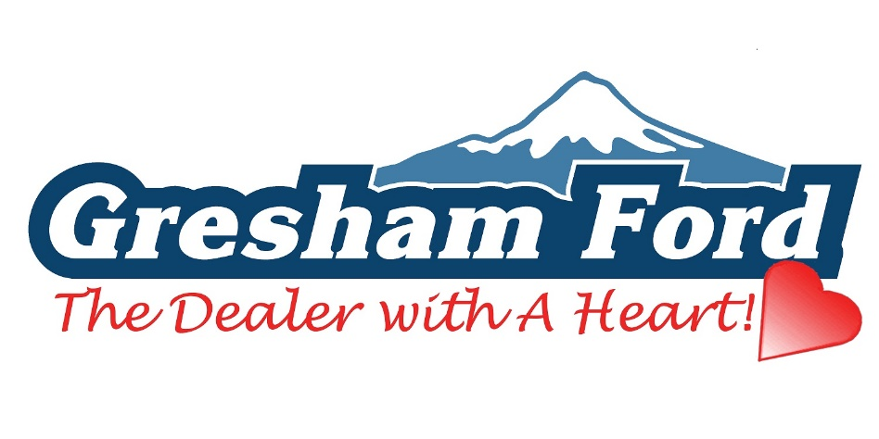
- $25 per person
- 8:30 AM Check-In, 9:00 AM Start
- USBF Open Rules
- Round Robin Format
- Limited to the first 16 Teams with Payment
- Trophies for 1st Place
- Make Checks Payable to Paesano Bocce Club
- Send Entry Form with Check to: Paesano Bocce Club, 10006 SE 40th Ave. Milwaukie, Oregon 97222
Hot Dogs and Hamburgers will be provided for lunch. Please Bring your own Beverages. This is a fund raiser and all money collected will go to building The Two New Bocce Courts.

